1, Mobile Testing

Python 2.7

Selenium web driver

Android Studio

Appium 1.7.2

Device: OPPO R11s – Android 7.0

2, Mobile Test – Running Result

User login successfully and view the first article without image

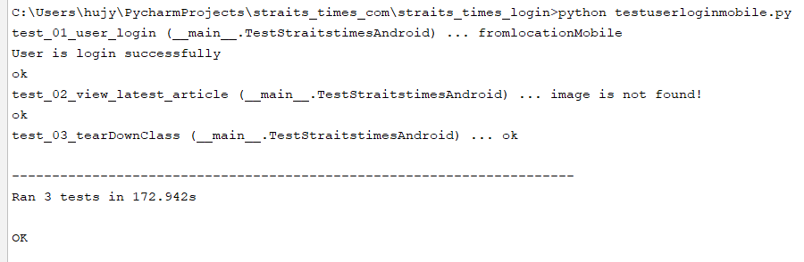

2, Mobile Test – Running Result

User login successfully and view the first article with image

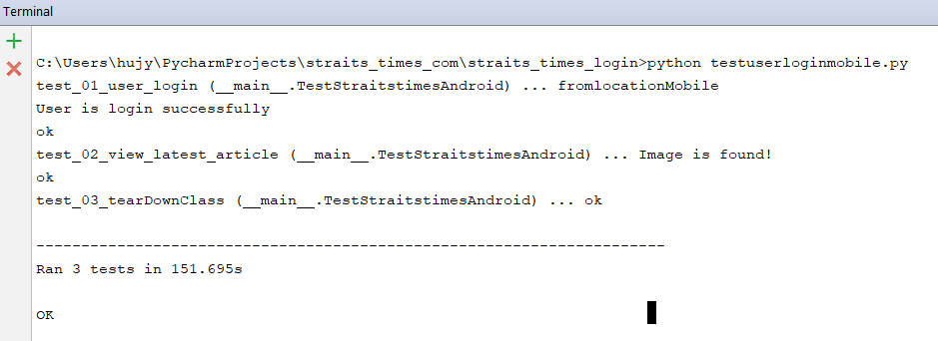

3, Web Test

Python: 2.7

FireFox: 59.02

Selenium web driver

4, Web Test – Running Result

